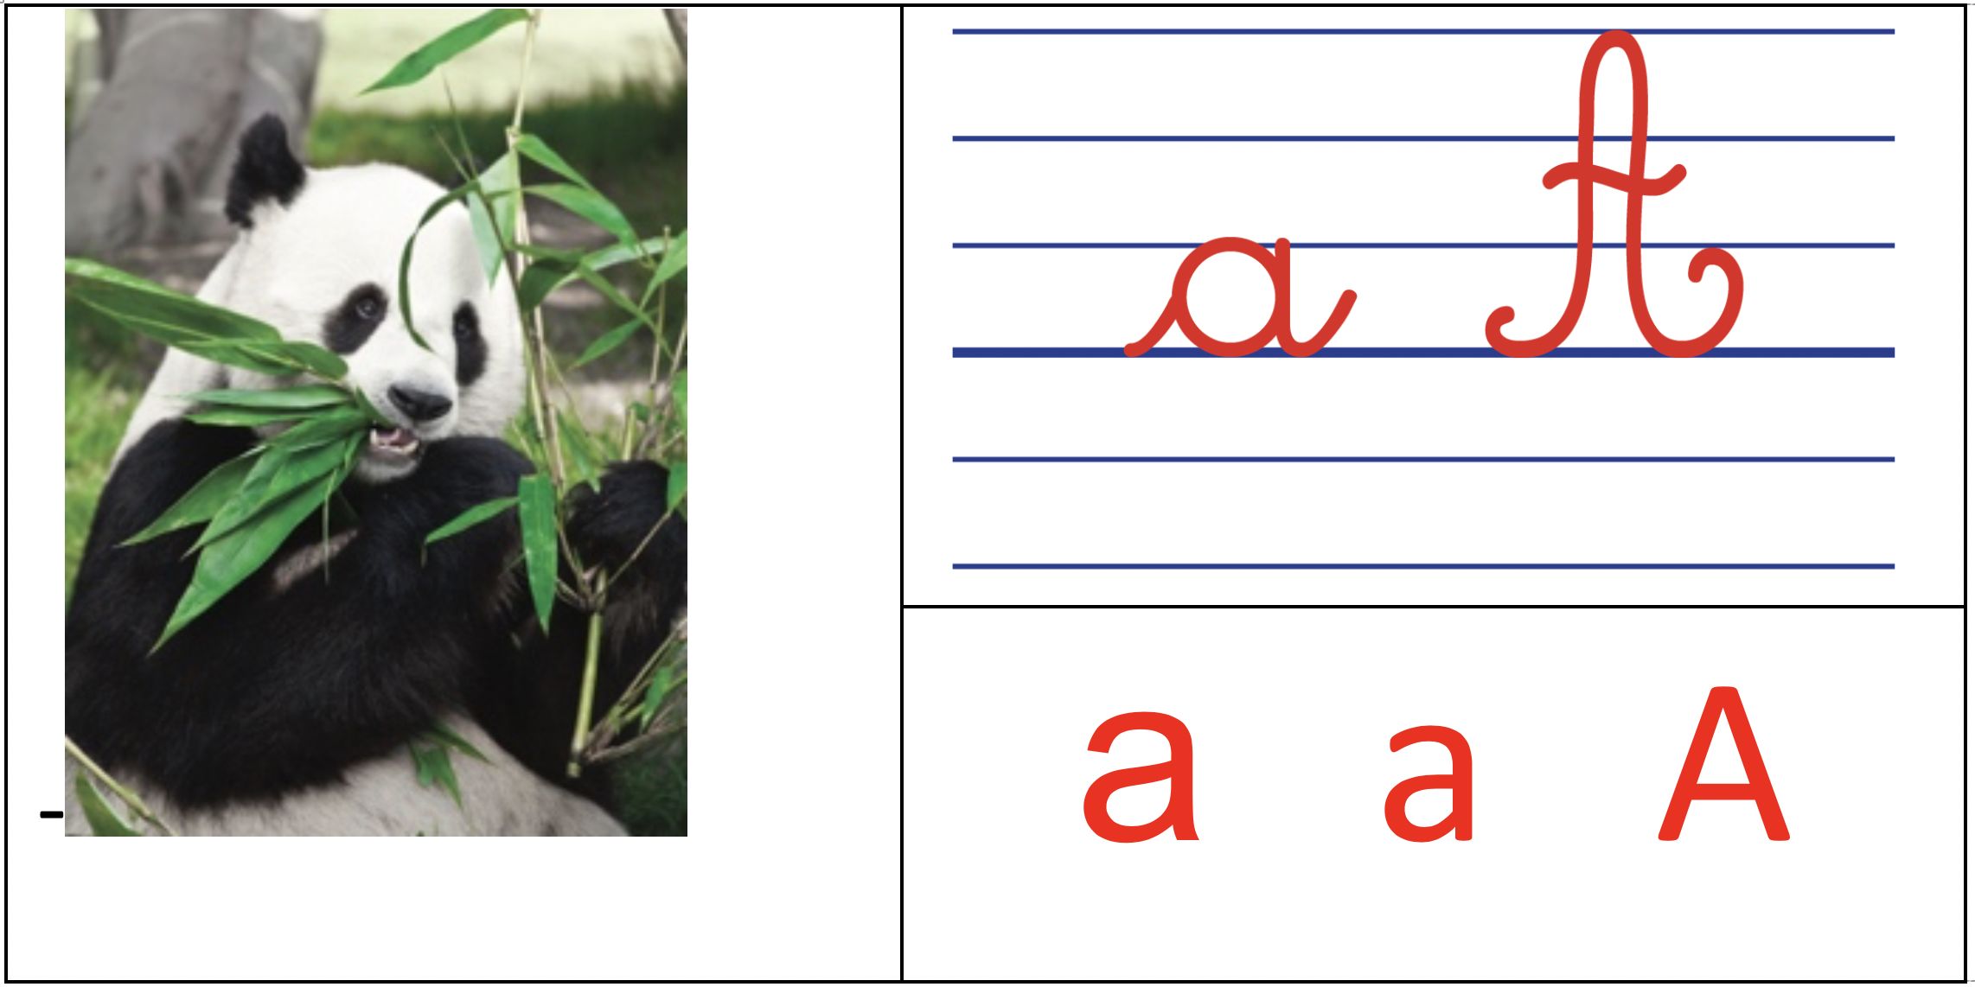 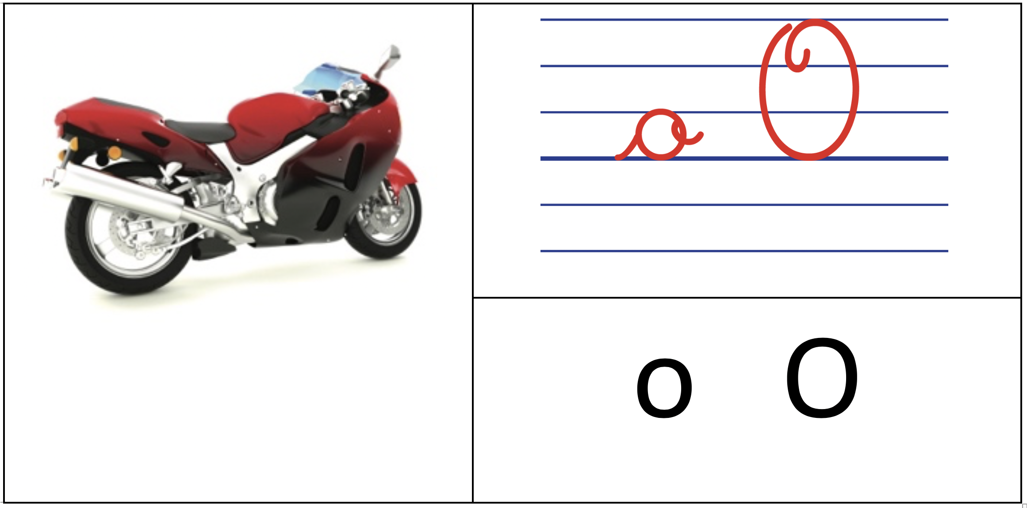

|  |  |
| --- | --- |
|  |  |
| i I |

|  |  |
| --- | --- |
|  |  |
| y Y |

|  |  |
| --- | --- |
|  |  |
| u U |

|  |  |
| --- | --- |
|  |  |
| é É |

|  |  |
| --- | --- |
|  |  |
| e E |

|  |  |
| --- | --- |
|  |  |
| f F |

|  |  |
| --- | --- |
|  |  |
| m M |

|  |  |
| --- | --- |
|  |  |
| s S |

|  |  |
| --- | --- |
| robinet |  |
| r R |

|  |  |
| --- | --- |
|  |  |
| l l L |